BUILDING NUCLEAR CONNECTIONS IN FRANCE

We have been in France for 28 days, and over a month since the walk began. We have had huge support from not just local people but globally the walk has been joined by people from Japan, Canada, German, France, Italy, Australia, Sweden, Scotland, England, Niger & the United States of America.

I cannot begin to share all of the stories we have heard – especially about the massive resistance from local people to stop the nuclear industry. Some of the stories we have heard have been of great success, while others have been more challenging and still continue today - 50 years since the beginning of French’s nuclear program

So far we have visited Cherbourg Nuclear Submarine Manufacturing Facility, La Hague Reprocessing Facility on the Normandy Coast, ANDRA – the storage of waste material from La Hague, Flamanville Nuclear Power Plant where they have 2 reactors and are now building a 3rd reactor which is the new European Pressurized Reactor (EPR), from here we walked along the proposed site of the THT Line (High Tension Line) that will carry 400,000 volts of electricity from Flamanville over 200 kilometres, a site of AREVA that makes the canisters to hold the fuel rods needed for the power plants, Chinon Power Plant that has 4 operational MOX fuel reactors and 3 reactors that are being decommissioned. For further information on these facilities and the local campaigns check our webpage for updates on www.footprintsforpeace.net
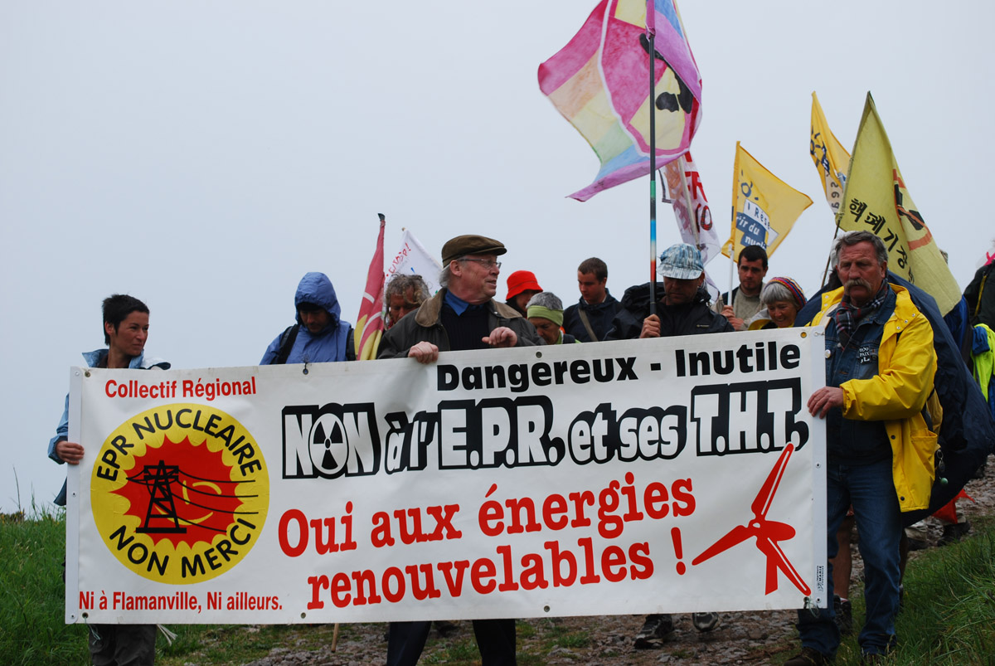
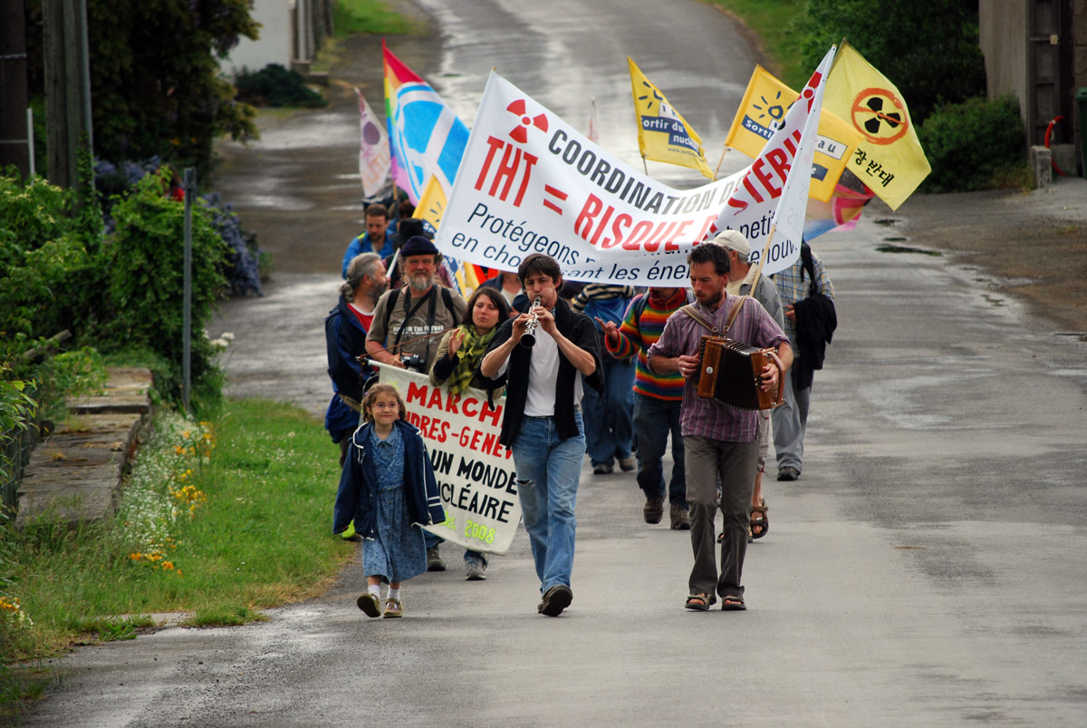

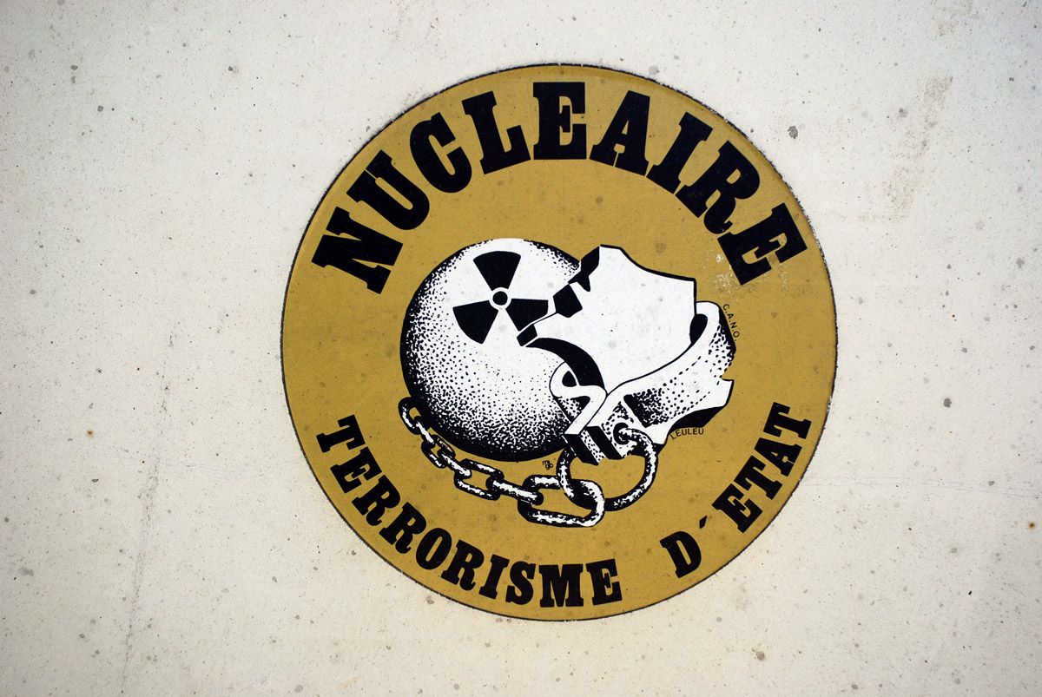
France made the decision to go massively for nuclear power in 1973. The opposition to nuclear power was largely overridden with rhetoric of energy independence. But in fact France imports all of its uranium. France is the 3rd highest importer of Australia’s uranium. France’s less than adequate public checks on the massive nuclear expansion was made much easier by the fact that it had just one electric utility – Electricite de France (EdF) – that was 100% government owned. Today EdF is over 80% government owned!! Cogema – the reprocessing company was also 100% government owned. Today EdF is part of the conglomerate AREVA – which is more than 80% French Government owned.

We have found out many interesting stories that make sense as to why there is a resurgence in nuclear power – money, greed and power of family affairs!! The head of AREVA is the god-father to the French President Nicolas Sarkozy’s, children. The British Prime Minister – Gordon Brown’s brother now works for Electricite de France (EdF).

People are horrified to hear about the role Australia is playing in fuelling this industry through the mining of Uranium. Some people are aware of Australian companies trying to gain access to uranium deposits in Niger while causing major problems for the Tuareg people. But many are unaware of the same exploitation happening in Australia, with uranium mining happening in World Heritage listed areas and the massive use of water happening in some of the driest regions of Country.

We are continually speaking with the media and people on the streets through our street flyers and in organised public meetings about the lack of respect towards Aboriginal Peoples and the environment through the uranium mining and the governments commitment in opening Australia up to an unprecedented uranium mining boom. Linking the beginning of the nuclear chain with the campaigns here in France & globally has been a strong statement made by all walkers.
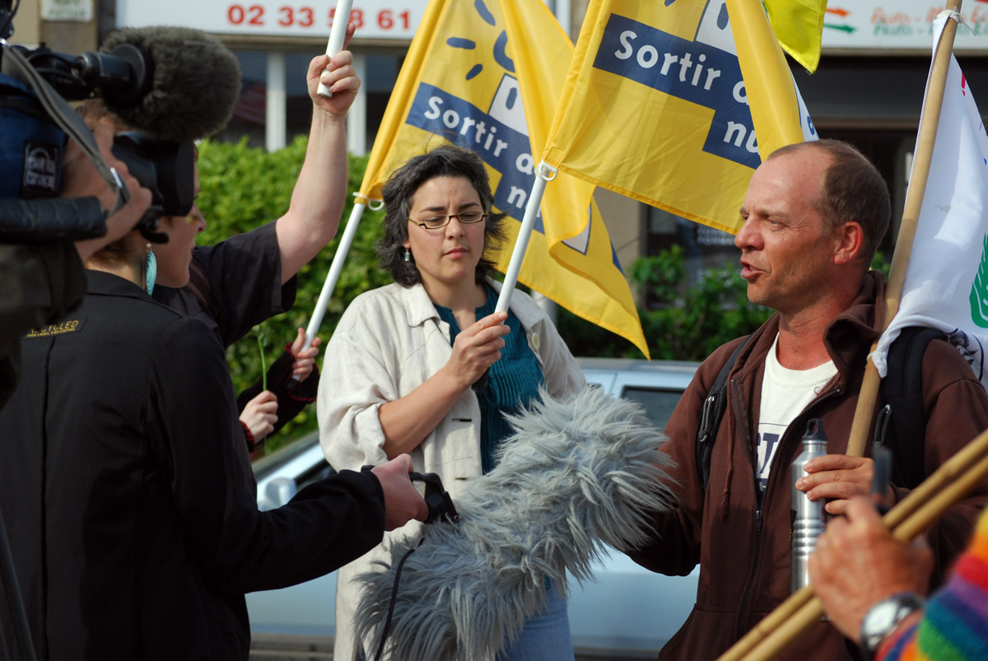

Recently we have received a copy of Scott Ludlam’s “Climate of Hope” that has been translated through sub-titles into French and will now be screening this at the local public meetings and distributing this DVD as much as we can. yeh yeh!!

We have been invited by the group we are working with Sortir du Nucleaire to participate in a 2 day conference in Paris for representatives in surrounding countries to meet and discuss how to stop the massive resurgence in nuclear power here in Europe. The organisers of this event would like to include in their campaign the connection with Niger and Australia through the uranium mining issue to create a global awareness of the devastation the whole nuclear chain creates and solidarity with the people who are affected by the mining.

In Geneva the walk has been asked to meet the Secreteriat of the Conference on Disarmament to present them with a document to explain our global action on how the nuclear cycle contributes to weapons proliferation and the need to eliminate the nuclear industry as the main point to disarmament.

We have also been asked by Sortir du Nucleaire to attend their week long summer camp during August to host a workshop about the nuclear issues in Australia. This will be a great opportunity to re-visit and re-connect with the local people who have organised for us on this walk.

We feel that we are really building strong connections with the French anti-nuclear activists and are creating great awareness of about what is happening in Australia & globally with the local people.
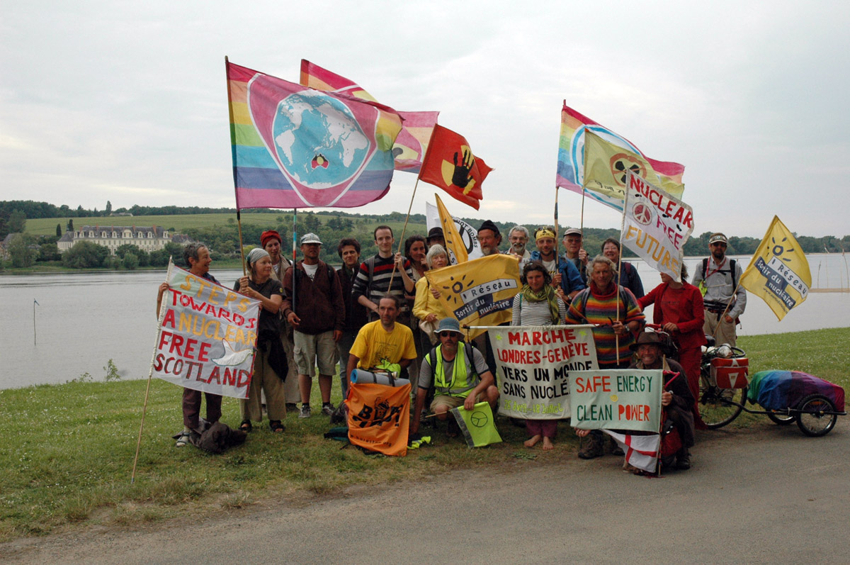

Thank you to all that continue to send messages, prayers and support for us to continue walking. Donations will be greatly received and can be paid directly into our account via paypal on our webpage: www.footprintsforpeace.net Thank you.

